**Predicting the Ending of a Sporting Event from Traffic**

Nick Romano, [nromano@bellarmine.edu](mailto:nromano@bellarmine.edu)

Trevor McCormick, [tmccormick2@bellarmine.edu](mailto:tmccormick2@bellarmine.edu)

**ABSTRACT**

Up to 150 word summary of your project.

1. **INTRODUCTION**

The data set that we are working with is the Dodgers Loop Sensor Data Set from the UCI Machine Learning Repository. The Dodgers Loop Sensor Data Set came with three files: Dodgers.events, Dodgers.data, and Dodgers.name. The Dodgers.events file is a comma separated file that contains entires of the date, starting time, ending time, total game attendance, opponent, and result of the Los Angeles Dodgers’ home games for the 2005 MLB season. The Dodgers.data file is a comma separated file that contains entries of car count for the 101 North Freeway Glendale on ramp at 5-minute intervals from April 10, 2005 to October 1, 2005 which was just before the first Dodgers home game and last Dodgers home game. The Dodgers.name file is just a file that describes the other two files.

Given the 2005 schedule and the traffic count of 5 minute intervals, and further knowing that the fact that the Glendale on ramp picks up the game traffic around the time of a Dodgers home game ending, our goal is to try and predict whether a Dodgers home baseball game had just ended.

1. **BACKGROUND**

The Los Angeles Dodgers play their home games at Dodger Stadium in Los Angeles, California. Using censor data from the Freeway Performance Measurement System (PeMS), which is an online traffic database that gathers traffic data from sensors, Jon Hutchins, the creator of the data set, was able to gather a count of cars on 5-minute intervals for the Glendale on ramp for the 101 North Freeway. Jon Hutchins notes in the Dodgers.name file that the Glendale on ramp to the 101 North Freeway is near Dodger Stadium to see an increase in the flow of traffic for the on ramp but is not too heavily used by the total game traffic. Furthermore, Jon Hutchins points out that the Glendale ramp is an on ramp and you can see traffic from a Dodgers game around the end of a Dodgers home game. Using Google Earth, we believe to have found the ramp that the data was collected on. In Figure One, the red pin on the map is a on ramp for the 101 North Freeway just off Glendale Boulevard and to the right of the pin is Dodgers Stadium. With the traffic data for the Glendale on ramp, the attribute that the author was trying to predict was the presence of a Dodgers baseball game.

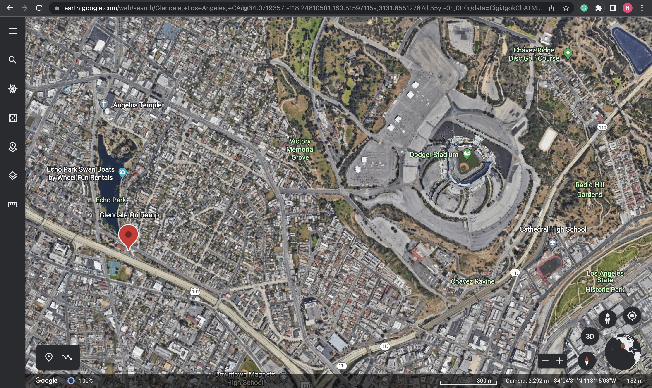

**Figure 1: The 101 North Freeway Glendale on ramp and Dodgers Stadium (Google Earth)**

1. **EXPLORATORY ANALYSIS**

This section will be similar to your exploratory analysis project. First, provide a summary of the data set similar to your first exploratory analysis: *e.g. this data set contains 398 samples with 7 columns with various data types*. In this summary, provide the data types of your columns (in a table) and then rather than providing tabular statistics and plots for each variable, provide only statistics and plots that seem unusual. For example, if one or two variables have significant missing values or the distribution of the variable is skewed or looks unusual note that. Provide the unusual statistics or plots in this section. Provide any other appropriate plots (e.g. correlation matrix, heatmaps, bar charts, etc.) that you deem necessary.

**Table 1: Data Types**

|  |  |
| --- | --- |
| *Variable Name* | *Data Type* |
| Week_Day | Int64/Ordinal |
| Hour | Int64/Interval |
| Minute | Int64/Interval |
| Traffic_Count | Int64/Ratio |
| Game_Ended | Int64/Nominal |

1. **METHODS**

In this section, describe how you prepared the data for your model and performed multiple experiments using different parameters for the model(s).

* 1. *Data Preparation*

Describe how you prepared the data for your model. For example, you might need to normalize the data, so variables with wider ranges of values don’t overshadow variables with smaller ranges. If you decide to drop variables from the model or create variables from existing columns, explain the process and the reasoning behind those decisions.

* 1. *Experimental Design*

You will run your model several times with different parameters to see what different results you get. In a table, describe your experimental parameters. Three or four experiments are sufficient. This is where you will describe how you divided your data into train, validate and test data sets. For example:

Table 2: Experiment Parameters Logistic Regression

|  |  |
| --- | --- |
| **Experiment Number** | **Parameters** |
| 1 | All four (4) raw features with 80/10/10 split for train, validate, and test |
| 2 | All four (4) raw features with 70/15/15 split for train, validate, and test |
| 3 | All four (4) raw features with 75/12.5/12.5 split for train, validate, and test |

Table 3: Experiment Parameters Random Forest

|  |  |
| --- | --- |
| **Experiment Number** | **Parameters** |
| 1 | All four (4) raw features with 80/10/10 split for train, validate, and test |
| 2 | All four (4) raw features with 80/10/10 split for train, validate, and test |
| 3 | All four (4) raw features with 70/15/15 split for train, validate, and test |
| 4 | All four (4) raw features with 70/15/15 split for train, validate, and test |

* 1. *Tools Used*

Describe all of the software tools you used to perform your data preparation and model implementation. For example:

The following tools were used for this analysis: Python v3.8.8 running the Anaconda 4.12 environment for Apple Macintosh computer was used for all analysis and implementation. In addition to base Python, the following libraries were also used: Pandas 1.2.4, Numpy 1.20.1, Matplotlib 3.3.4, Seaborn 0.11.1, SKLearn 0.24.1, and Patsy 0.41. Provide a brief explanation of why you chose these tools.

1. **RESULTS**
   1. *Classification Measures*

Provide the classification measures for each experiment. For example, you could provide a contingency table for each model to measure how well it classifies data. You could also do an ROC curve (using SciKit Learn). You need to demonstrate how you are measuring the success/failure of the models.

* 1. *Discussion of Results*

Discuss which of your models provided the best classification (or some other outcome if not classification). Explain why you think your best model was the best and why your worst model was the worst.

* 1. *Comparison of Models*

Since you are running at least two machine learning classification models, compare the models and explicitly discuss which model was the best.

* 1. *Problems Encountered*

No project goes perfectly smooth. Discuss any problems you had with obtaining the data, preparing the data, implementing the model, or evaluating the model. **It would be highly unusual to indicate that you had no problems.**

* 1. *Limitations of Implementation*

Discuss the limitations of your model(s). Are there reasons your models might not be the best way to predict the target data? What other models might work better?

* 1. *Improvements/Future Work*

What would you like to do to improve your model in future work? Some items you might consider discussing are performing more experiments, using different models, adding or removing variables, finding a different data set, etc.

1. **CONCLUSION**

Finish up with a paragraph or two of summarizing your problem, the results and your conclusions (good model, bad model, needs more work, etc.).

**REFERENCES**

List any websites, books, articles, etc. that you found useful while you worked on this project. It is not necessary to cite the references in the paper unless you specifically mention it in the text.

*Division of Labor*

In this section after you references, provide a paragraph or two outlining what each team member did on this project. Please don’t tell you both did everything! Be honest about who did what.

**Other directions:**

1. 10-pt, Times New Roman, 1” margins all around (if you use this template you are already set).
2. **Ensure all tables and figures are numbered appropriately and referenced in the text.** See examples above and below.

|  |  |
| --- | --- |
| **Figure 1: Comparison of X/Y from dataset (single plot) (8 pt.)** | **Figure 2: (a) Function Output (b) A against B (multiple plots) (8 pt.)** |